Experiment 20
Program:
import cv2
import numpy as np
# Read the image in grayscale
img = cv2.imread("image.jpg", 0)
# Create a kernel (structuring element)
kernel = np.ones((5,5), np.uint8)
# Apply dilation
dilation = cv2.dilate(img, kernel, iterations=1)
# Display images
cv2.imshow("Original Image", img)
cv2.imshow("Dilated Image", dilation)
cv2.waitKey(0)
cv2.destroyAllWindows()
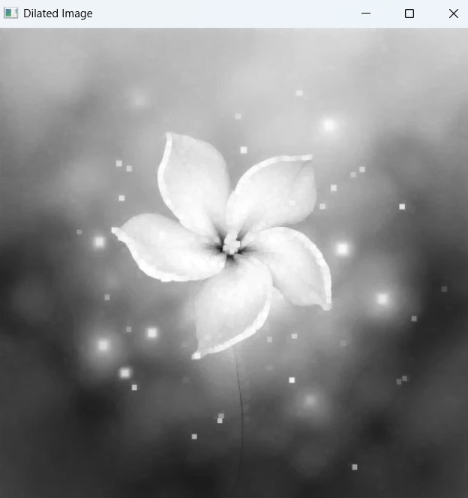
Output:

